IMMC2026 TEMPLATE FOR THE 4-PAGE MANUSCRIPT

Name Surname1*, Name Surname2, Name Surname3

1University Name, City, Country
²University Name, City, Country
3University Name, City, Country

Keywords: Ceramics, Composites, Metals, Polymers

Abstract
The manuscript (max. 4 pages) should contain abstract, introduction, experimental procedure, results and conclusion following the title, author name(s), affiliation(s) and keywords. Please write at least three keywords. Additional parts or subheadings are under the initiative of author(s) in accordance with the content integrity. The manuscript is in two column format after the keyword line.

- Introduction
The title must be 14 pt., bold, centered and in all caps. The typeface of the manuscript should be Times New Roman, 10 pt. and justified. It is allowed to use lower-case letters for element abbreviations etc.
Author name(s), affiliation(s) and keywords must follow the title, and they should be 10 pt. and centered. Superscript numbers are used for the authors from different affiliations. Each affiliation should be put on a separate line with a superscript number. The name of the corresponding author who will present the paper must be indicated by an asterisk (*). Leave a blank line between title, author name(s), affiliation(s) and keywords.

Experimental Procedure
All equations should be typed flush left and numbered in parentheses at the right-hand margin. SI units must be used. Equations separated from the text by one blank line of space above and below.

Ca(CO)3 → CaO + CO2 (1)

First-level subheadings are flush left, bold and numbered (except Abstract, References and Acknowledgment) and first letter of each word capitalized. All headings should be separated from the text by one blank line above.

Second-level subheading
Second-level subheadings are flush left, bold, numbered and first letter of each heading capitalized.

Third-level subheading are flush left, underlined and first letter of each heading capitalized.

Results and Discussion
Tables should be prepared in the form given in Table 1. The font size is 10 pt., however, down to 8 pt. sizes are acceptable to fit the data, if necessary.

Table 1. Chemical analysis of the Material (wt%)
Fe | Si | Cu | Mn | Mg
1.02 | 7.54 | 3.45 | 0.36 | 0.32

Figures should be prepared in the form given in Figure
1. Graphs and photographs should be in high quality. Colored graphs and photos are acceptable.
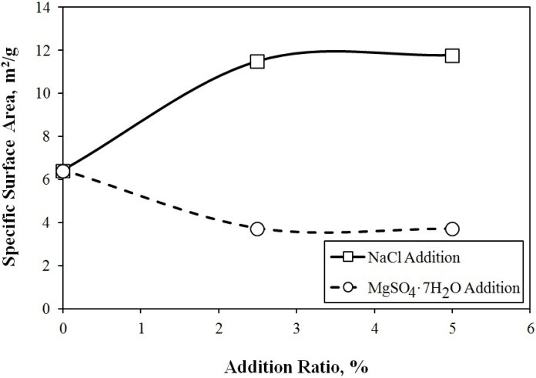
Figure 1. Variation of specific surface area with % addition

4. Conclusion
Page size is 215.9 mm x 279.4 mm. Top and bottom margins are 25 mm, left and right margins are 20 mm. Please do not give numbers to the pages.

Acknowledgment
Acknowledgment part can be added to the manuscript. References should be given with the order where it is used in the text body. Examples of reference types are given below. [1] corresponds to journal articles, [2] conferences proceedings and abstracts, [3] books, [4] chapters in the books, [5] thesis, and [6] websites.

References
- U. Demircan, B. Derin and O. Yucel, Materials Research Bulletin, 42 (2007) 312-318.
- A. Turan, F.C. Sahin, G. Goller and O. Yucel, Spark Plasma Sintering of TiB2 Ceramics, 13th Conference of

the European Ceramic Society (ECerS XIII), 23-27 June 2013, Limoges-France, pp. 1042-1046.
- W.G. Davenport, M. King, M. Schlesinger and A.K. Biswas, Extractive Metallurgy of Copper, Pergamon, 2002, Oxford, United Kingdom, pp. 12, 34-56.
- D. Sherman, D. Brandon, Mechanical Properties and their Relation to Microstructure, Ed. R. Riedel, Handbook of Ceramic Hard Materials, Wiley-VCH, 2000, Weinheim, Germany, pp. 13-34, 45, 345-400.
- S. Altinok, Thermal Plasma Synthesis of Boron Carbide, M.Sc. Thesis, Middle East Technical University, 2018, Ankara, Turkey, pp. 34-45.
- <http://www.metal-powder.net> Dated: 08.11.2019.

